Web Technologies

Name: Nauman hanif

Id: F2021266087

Section: v1

Assignment: #1

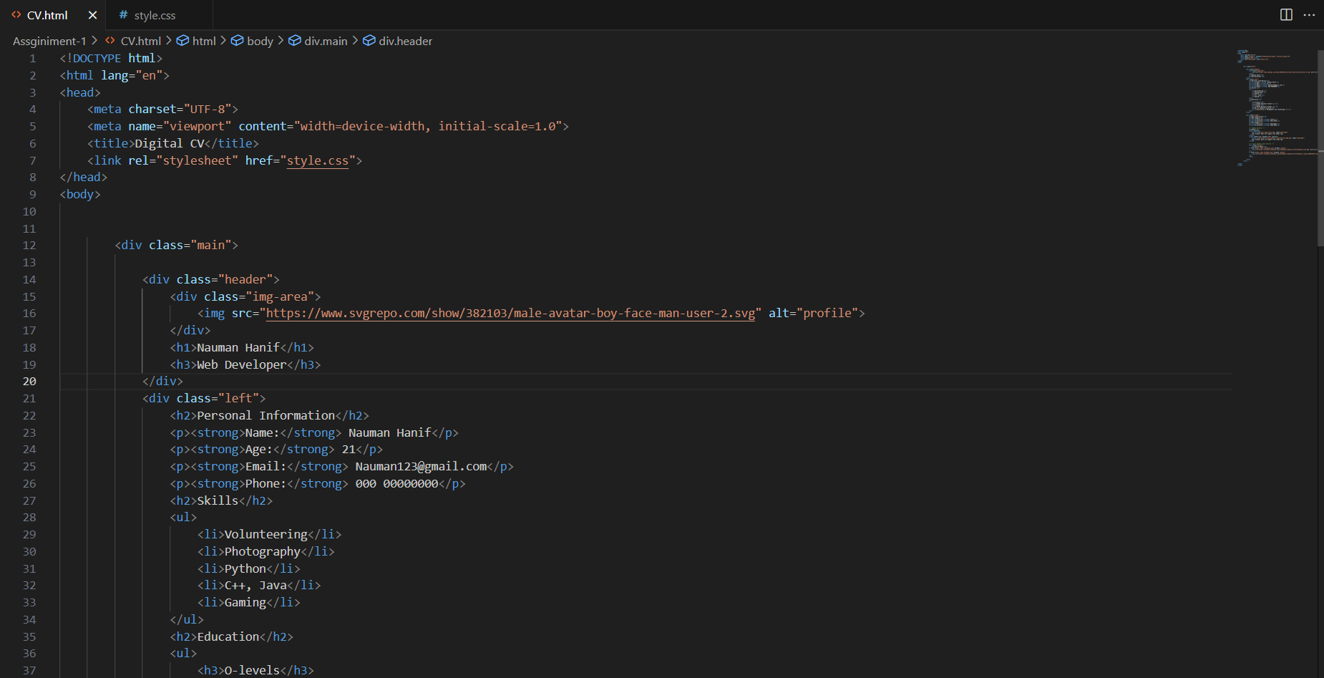

Website view: